## **Learning objectives**

* Navigation controllers
* Tab bar controllers
* Containing one type of view controller inside of another.

## **Introduction**

You’ll be building a weather app that will hold 5 tabs, each one for a different city.

The view controller for each tab will be a navigation controller holding a description of the weather (sunny, cloudy, fog, etc.) and an icon of that weather description. The user also has the ability to navigate back and forth to a view controller to get more detailed info on that cities weather, ex) current time, current temperature, chance of precipitation, etc.

We are going to hardcode the weather data in this version of the app.

## **Setup**

Download the starter project from the classroom - Assignment4.zip

## **Instructions**

We are going to do this whole assignment programmatically, ie) no storyboards.

Add a City Class with weather information properties. *(already done!)*

In your scene delegate, initialize city objects for Vancouver and 4 other international cities.

In your scene delegate, create a tab bar controller and set it as the root view controller.

Create a view controller class called CityViewController. *(already done!)*

Next, initialize five CityViewController instances, one for each city. Create navigation controllers for each of the city view controllers, set the root view of those navigation controllers to the corresponding city view controller, and add each city's navigation controller to your tab view controller. *(already done!)*

Create another view controller called DetailsViewController. This one will be one to just show additional weather data.

Back in the city view controller's class implementation file, implement a showWeatherDetails method that creates an instance of the DetailsViewController and tells the city view controller’s navigation controller to push the weather details view controller onto its view controller’s stack. Before telling it to push it onto the stack, set the properties of the details view controller.

## **Example Screenshots**

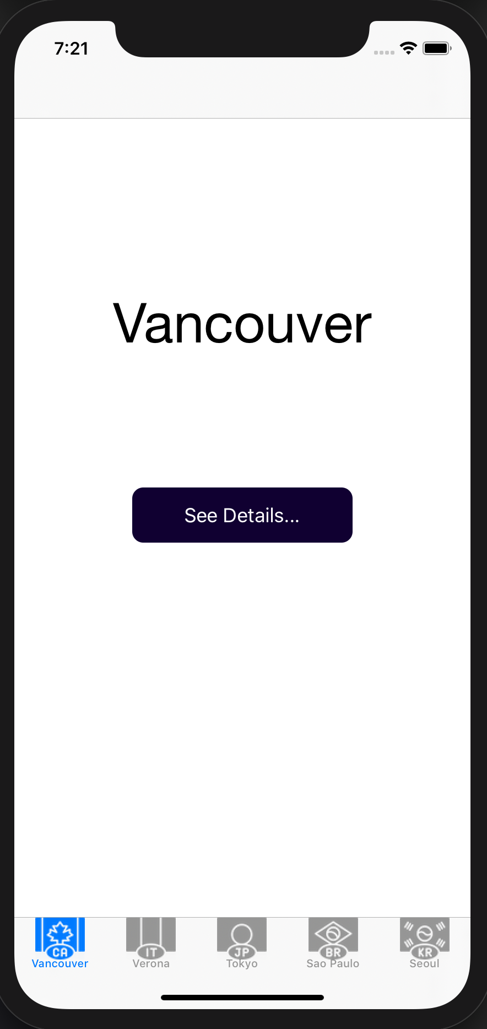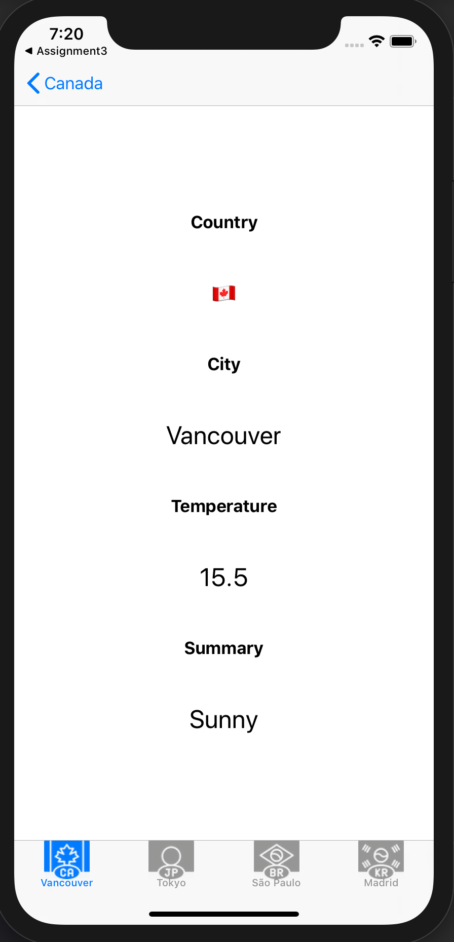

**Optional**

* Create custom view controller transitions, first non-interactive and then interactive, using the tutorial here (Objective-C version): <http://www.objc.io/issue-5/view-controller-transitions.html>

## **Resources / References**

1. [View Controllers (Apple)](https://developer.apple.com/library/ios/documentation/WindowsViews/Conceptual/ViewControllerCatalog/Introduction.html)
2. [UINavigationController Class Reference](https://developer.apple.com/library/ios/documentation/uikit/reference/UINavigationController_Class/Reference/Reference.html)
3. [UITabBarController Class Reference](https://developer.apple.com/library/ios/documentation/uikit/reference/UITabBarController_Class/Reference/Reference.html)